Repair Tracker Online DBMS BUSINESS CASE

ADAM DUROS, OWNER

REPAIR TRACKER ONLINE, LLC .

Omaha, NE

VERSION 1.0

03/02/2019

**PROJECT BUSINESS CASE**

|  |  |  |  |  |
| --- | --- | --- | --- | --- |
| **VERSION HISTORY** | | | | |
| **VERSION** | **APPROVED BY** | **REVISION DATE** | **DESCRIPTION OF CHANGE** | **AUTHOR** |
| 1.0 | Adam Duros | 03/02/2019 | Initial Draft | J.Bergmann, E.Hollinger, S.Richardson |
|  |  |  |  |  |
|  |  |  |  |  |
|  |  |  |  |  |
|  |  |  |  |  |
|  |  |  |  |  |
|  |  |  |  |  |

|  |  |  |  |  |  |
| --- | --- | --- | --- | --- | --- |
| **PREPARED BY** | Jeremy Bergmann | **TITLE** | BIA Student - Creighton University | **DATE** | 03/02/2019 |

# EXECUTIVE SUMMARY

## DESCRIPTION OF CLIENT

|  |
| --- |
| Repair Tracker Online, LLC (RTO) is a Business-to-Business (B2B) mobile web product that allows repair businesses to record, advertise and promote the work they’ve done for their customers.   This is done via QR codes that link a repair shop to a repaired entity, such as: vehicles, homes, boats, et al., combined with a mobile application that stores invoice information. The goal of the project is to makes advertising and managing customer relationships easier for business in any repair-based industry.  This project focuses on the design and development of a database management system (DBMS) that enables data storage and retrieval for front-end mobile development and presentation. This includes documentation of the business case & requirements, project plan & timelines, solution design documentation (ERD and relational diagrams), physical implementation of the database (via SQL code), and a web-based prototype (end-product) with design sketches. |

## CLIENT’S PROJECT NEEDS

|  |
| --- |
| Adam needs help with the backend development of his product. He currently does not have a database and having one created for him would help streamline his project. |

## 

## ADDITIONAL TECHNOLOGY

|  |
| --- |
| AngularJS will likely be needed to finish the app. Similarly, HTML/PHP may be needed to add to the already existing website. |

## 

## BUSINESS CASE

|  |
| --- |
| The purpose of the business case is to document the justification for the undertaking of a project, based on the estimated cost of development and implementation against the risks and the anticipated business benefits and savings to be gained.  For this project, the intended benefit of the project is to assist with the development of an initial Repair Tracker Online mobile-web product; By providing a DBMS solution that manages, store and displays the required information for B2B end-user consumption. |

## BUSINESS CASE SPONSOR

|  |
| --- |
| Adam Duros, Owner of Repair Tracker Online, LLC. Adam is the sponsor of the business case to build a DBMS system to supplement his company’s mobile-web products. Additionally, Adam can/will answer all questions about strategic direction and implementation of the database and end-product (DBMS + interface). |

## 

## 

## STRATEGIC OBJECTIVE

|  |
| --- |
| The project contributes to the strategic plans of RTO through the enablement on an initial mobile web product. With an initial product, the RTO mobile-web product can be improved through direct user feedback and demonstrated to potential investors – leading to funding for additional development. |

## PROJECT REQUIREMENTS

|  |
| --- |
| From a functional standpoint, the key project requirements are as follows:  * Ability for businesses to record (via service record) and attach photos/invoices of their repair work.  * Generation of a unique QR Code, based off VIN and/or other UID  * Ability for customers to validate completed work  * To view work completed by other repair businesses (B2B)  * To Advertise/Market and allow repair shops to promote their work they’ve completed for clients.  * Ability to search for repaired entities, via VIN lookup and/or QR code functionality.  * Ability for owners of a repaired entity to transfer service records, upon new ownership. |

## BUSINESS RULES

|  |
| --- |
| Following the requirements gathered in the previous section, the business rules, entities and relationships that will guide the constraints in the DBMS solution are as follows (Entities are in **BOLD**):  *“Multiple* **vendors** *can have* **relationships** *with multiple* **owners,** *or no* **owners** *at all*”  *“**Multiple* **owners** *can have* **relationships** *with multiple* **vendors,** *or none at all*”  *“**A* **vendor** *can generate multiple* **service** *records or no* **service** *records at all*”  *“A* **service** *record must be attributed to only one* **business**”  **“***A* **service record***may contain many***invoices**, *or none at all”*  **“***multiple* **invoices***must belong to only one* **service** record*”*  **“***An* **invoice** *may contain many* *repair* **images***, or no repair* **images** *at all”*  **“***Multiple repair* **images** *must belong to only one* **invoice** *record”*  *“A* **Owner** *can approve multiple* **s****ervice** *records or no* **service** *records at all.”*  *“A* **service** *can be approved by only one* **Owner***”*  *“A* **vendor** *must register for at least one (or many)* **accounts***”*  **“***Multiple* **accounts** *must be registered by only one* **vendor** *record”*  *“A* **repair subject** *can be contained in multiple* **service** *records, but must have at least one* **service** *record.”*  *“A* **service** *record must service* *only one* ***repair* subject***.”*  *“***Vendors** *can run multiple advertising/market* **campaigns** *or* **no campaigns** *at all.”*  *“Multiple marketing* **campaigns** *may be run by zero or more* **vendors***.”*  *“An* **invoice** *can record multiple* **repairs,** *but* *must record at least one”*  *“Multiple* **repairs** *are recorded on an* **invoice,** *but it must record at least one* **repair***”*  *Assumptions*   1. **Repair subject** is a variety ofrepairedentities, including vehicles, homes, trailers, boats, motorcycles, etc. 2. Multiple invoices can be part of a service record – Transaction date/time of service 3. A vendor (repair business) does not need to have customers and/or service records to be in the RTO dbms. 4. A business must have an account to be a vendor in the RTO dbms, but not necessarily to view results 5. One “primary” owner exists per **repair subject** 6. A **Repair subject** needs at least 1 service record to be stored in the RTO dbms. |

## DATA SOURCES

|  |
| --- |
| RTO’s main data source is data obtained from repair invoices that are uploaded to the platform, via image and/or pdf files. Adam and/or our team will partner to reproduce this information in the database environment, via manual information gathering and input.  Next, the mobile-web interface will produce data, including user profiles, login information, payment information, and product usage details. Since the mechanism to capture this information doesn’t currently exist, our team will generate the information needed to populate these fields, in a manner that’s meaningful for prototype purposes. |

## ASSUMPTIONS AND CONSTRAINTS

|  |
| --- |
| RTO’s current product is a mobile app developed in Angular Javascript (v4), using the Ionic framework. A visual of how the relationship works is displayed below:  From Angular to mobile app  If the project team is unable to utilize existing code, we will recreate the mobile app’s workflow and develop the end-product as a prototype, in another web-based language. (such as html, php & javascript)  Additionally, the cost to Repair Tracker Online, LLC is $0 – since the client carries little risk, there will be no expectation upon project completion of a production-ready mobile-web solution. |

## PROJECT PLAN

# <https://docs.google.com/spreadsheets/d/1PibU8jL_FG3nts1aBcmaU8Hxe77GdVs5e88mEysq4kU/edit?ts=5c81913b#gid=1205859754>

## ENTITY-RELATIONSHIP DIAGRAM

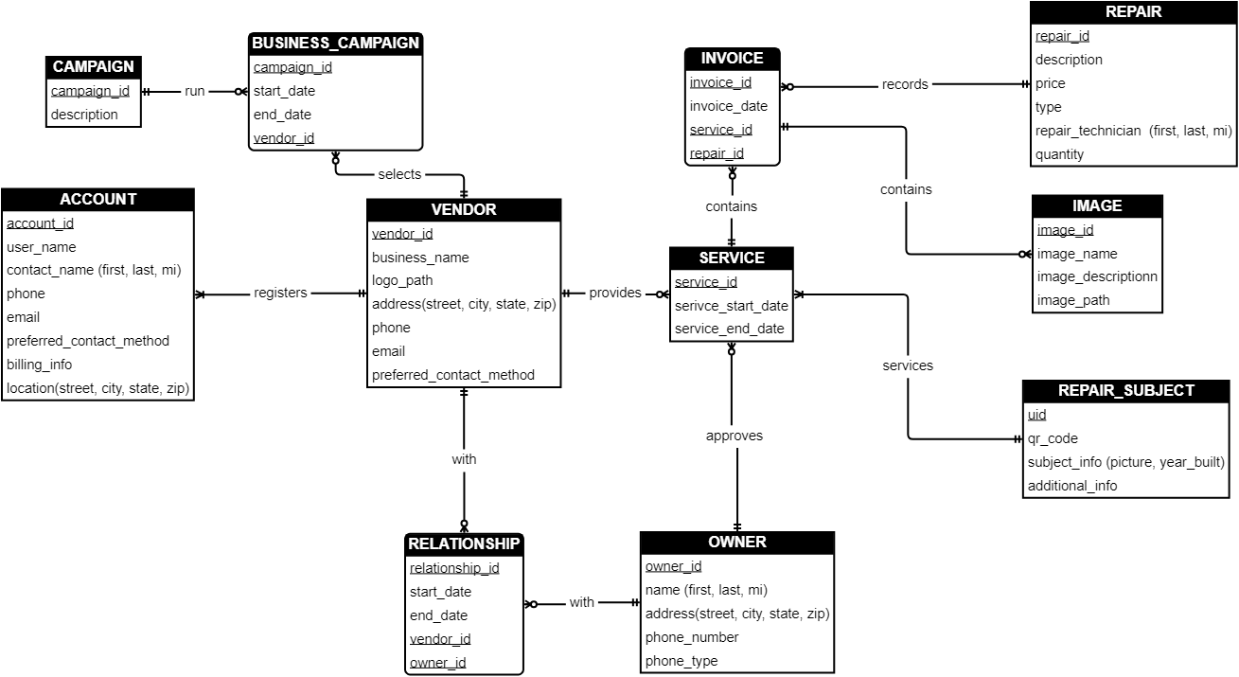

## RELATIONAL MODEL

